使用数组和dom操作完成以下表格在网页上的显示。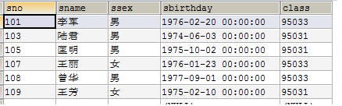
[“sno”,”sname”,”ssex”,”sbirthday”,”class”]
[
[101,”李军”,”男”,”1976-02-20&nbsp; &nbsp; &nbsp;00:00:00”,95033],
[103,”陆君”,”男”,”1974-06-03&nbsp; &nbsp; &nbsp;00:00:00”,95031],
[105,”匡明”,”男”,”1975-10-02&nbsp; &nbsp; &nbsp;00:00:00”,95031],
[107,”王丽”,”女”,”1976-01-23&nbsp; &nbsp; &nbsp;00:00:00”,95033],
[108,”曾华”,”男”,”1977-09-01&nbsp; &nbsp; &nbsp;00:00:00”,95033],
[109,”王芳”,”女”,”1975-02-10&nbsp; &nbsp; &nbsp;00:00:00”,95031],
]

